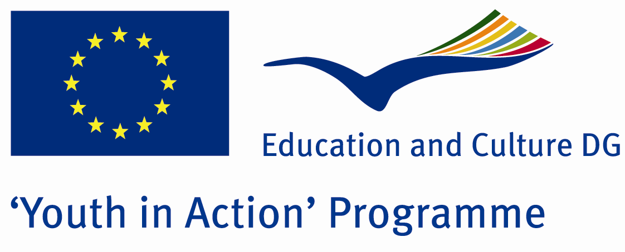

Hearth Eyes


ACTION 1.1 – Youth Exchange

30th September 2011- 06th October, 2011

Osmaniye, TURKEY

ACTION 1.1 - Youth Exchange

Please contact directly to;
adventurerpeacepigeons@gmail.com

Project Summary;

Natural disasters, and major destruction occurred without the influence of people killing people and property damage by natural events. These are drought, famine, severe cold weather, earthquakes, floods, landslides, avalanches, storms, hurricanes, volcanoes, forest fires and etc. Natural disasters, most countries have not known in advance caught unprepared, so the higher losses of life and property. These disasters occur all over the world, and collaborate, and improves the support of the people. Many countries help to get rid of this disaster and lots of people make a bridge, heart to heart.

The aim of our project is prepared for natural disasters, deliberate and cold-blooded people who will help in such situations is to create. So that each participant adds a wood this bridge.

If you want to join this project, please contact us..

Project Title; Hearth Eyes

Date and Venue ; 30th September 2011- 06th October 2011
Osmaniye, Turkey .

Target Group ; Municipalities, City Councils and Non-Governmental organizations,
youth groups,culture and art groups,e.t.c

Participants ; 5 people from each country (over 18 -25 ). Totally 8 countries.

Conditions ; Accommodation, board and programme costs will be financed through European Commission Youth in Action Programme ….Travel costs will be reimbursed in 70% (APEX Tarrifs). Organizations from all 27 EU member countries plus Liechtenstein , Norway and Iceland are eligible to take part.

Working language: English

Organizer; Adventurer Peace Pigeons

How to apply: If you are interested, please send your Part III forms to
by e-mail please. Scan Part3 format is enough for application. (Fulfilled Part III which you can find in the attachment, of course signed and stamped) ..

Next step 2;
Original send via regular post to this address please:

Ertan DERİN
Fevzi Çakmak Mahallesi Tuncer Sokak No:6 PENDİK/İSTANBUL/TÜRKİYE
e-mail : adventurerpeacepigeons@gmail.com
Mobile : 0090 542 393 93 90

If you have any questions you may contact with: adventurerpeacepigeons@gmail.com

Deadline for application; until 15th May 2011.

For Further information:
Contact Person
Ertan DERİN

Fevzi Çakmak Mahallesi Tuncer Sokak No:6 PENDİK/İSTANBUL/TÜRKİYE
e-mail : adventurerpeacepigeons@gmail.com
Mobile :0090 542 393 93 90

